Use this reference to view, add, and edit notes in the student record.

Student Notes are notes that faculty, staff, and administrators can add to student records that allow for internal documentation. These notes do not print on a transcript. Notes can be edited and deleted, as needed, depending on security access level. By default, students cannot view Student Notes on their record; however, note creators can adjust this setting to allow students to view on their account.

This guide covers the following:

Add Student Note 1
Option 1 1
Option 2 2
Option 3 4
View a Student Note 5
Edit a Student Note 6
Share a Student Note with the student 7
How Students see Student Notes 8

Add Student Note

Option 1

- Log into Workday. Navigate to the search bar and type “Add Student Note”. Then, select the task once it populates.

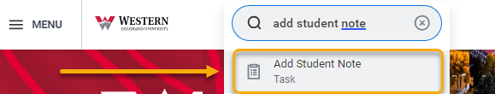

- Enter the name of the student and complete required fields. Click “OK”

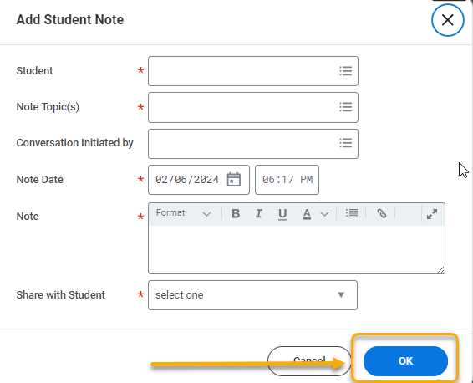

- Click “Done”.



Option 2

- Log into Workday. Navigate to the search bar and type “Student: [Student First Name] [Student Last Name]”. Then, select the student once it populates.

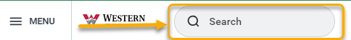

- Navigate to the student profile. Click “History”.

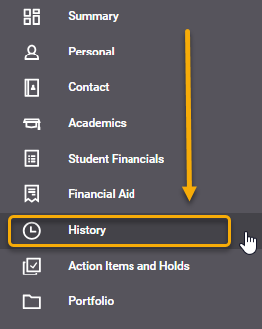

- Click the “Note History” tab and “Add Student Note”.

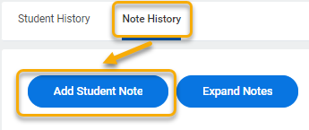

- Complete required fields. Click “OK”.



- Click “Done”.



Option 3

- Log into Workday. Navigate to the search bar and type “Student: [Student First Name] [Student Last Name]”. Then, select the student once it populates.



- From the left-hand menu, click “Actions”.

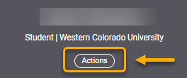

- Click the “Note” and “Add Student Note”.

.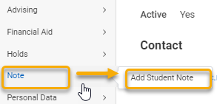

- Complete required fields. Click “OK”.



- Click “Done”.



View a Student Note

- Log into Workday. Navigate to the search bar and type “Student: [Student First Name] [Student Last Name]”. Then, select the student once it populates.



- From the left-hand menu, select “History”.

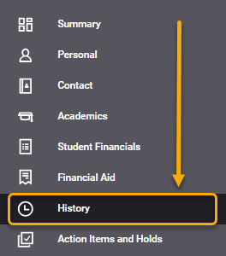

- Click the “Note History” tab to view all student notes, including who created the note and when.

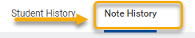

Edit a Student Note

- Log into Workday. Navigate to the search bar and type “Student: [Student First Name] [Student Last Name]”. Then, select the student once it populates.



- From the left-hand menu, select “History”.

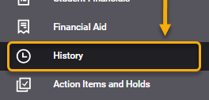

- Click the “Note History” tab to view all student notes, including who created the note and when.



- Identify the note you want to edit and click the Related Action button .
- Click “Student Notes”.
- Click “Edit”.

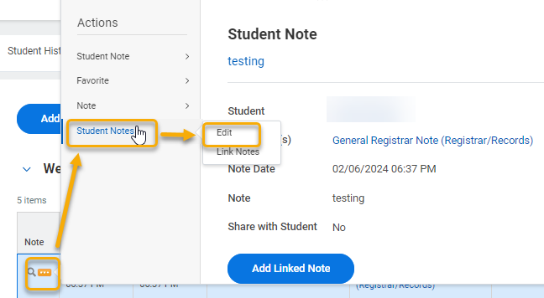

- On the Edit Student Note page, make edits. When finished, click “OK”.



- Click “Done.



Share a Student Note with the student

By default, students cannot view Student Notes on their record. However, you can choose to make a particular note viewable by the student on their account by following these steps.

In a new note, complete the required fields. At the bottom of the form, locate the Share with Student field and select “Yes”. Proceed with the remaining steps as detailed earlier in this guide.

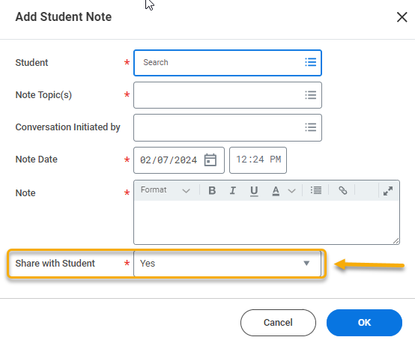

To share an existing note, locate the note in the Note History tab on the student’s record. Identify the note you want to share and click the Related Action button . Click “Student Notes” and click “Edit”.

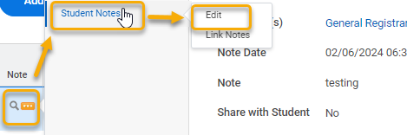

On the Edit Student Note page, locate the Share with Student field and set it to “Yes”. Proceed with the remaining steps as detailed earlier in this guide.

How Students see Student Notes

Students cannot see all Student Notes attached to their record. They can only see shared notes, which are posted to the History tab in their student profile. Follow these steps to guide students on viewing shared notes.

- From the student’s Academic app, click the profile picture in the top-right corner.



- Click “View Profile”.

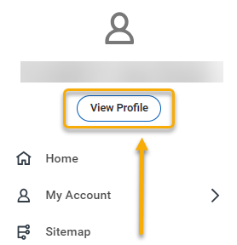

- Click “History” and click “Note History”. All shared notes are listed under the Note History tab.

